Industrial Activity

Industrial Activity Report: Visit to "Tasty World" – A Snack Manufacturing Industry
On our recent visit to "Tasty World," a snack manufacturing industry specializing in the production of chips and other snacks, we gained valuable insights into the various stages of snack production, which utilize manual, semi-automatic, and fully automated processes. This report details our observations and explains how each method contributes to the overall production.


1. Introduction to "Tasty World"
"Tasty World" is a mid-sized snack industry that produces a variety of popular products, including potato chips, tortilla chips, and a range of packaged savory snacks. The company uses a combination of production methods to cater to its demand, ensuring high efficiency while maintaining product quality and flavor consistency.

2. Raw Material Handling
The first stage of snack production is raw material handling. Potatoes, corn, and other grains form the base of many snacks. We saw three different methods in use:
- Manual Handling: Workers manually sort and wash the raw materials. Potatoes, for instance, are inspected for quality, size, and defects. This step ensures that only the best materials are used for the final product.
Semi-Automatic Handling: Conveyor belts transported raw materials into machines where they were washed and peeled, reducing manual labor while ensuring consistency. This stage combines human oversight with machinery to handle materials efficiently.
- Fully Automated Handling: In this phase, machines performed all tasks, from sorting, washing, and peeling to cutting potatoes. Sensors checked the quality of the materials, and rejected items were automatically removed. Automation improved both speed and precision.

3. Processing Stages
The main production process involved cutting, frying, seasoning, and packaging the snacks.

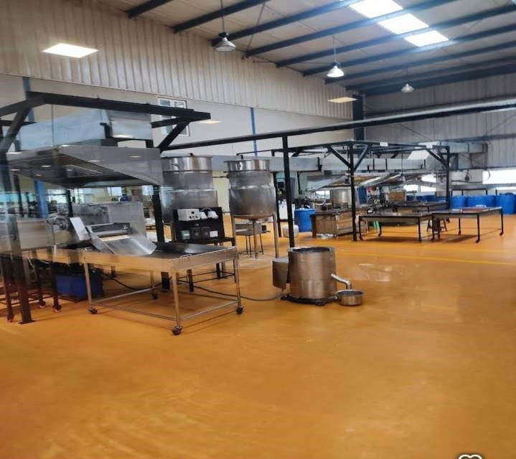

A. Cutting and Shaping
- Manual Process: In smaller batches, workers manually sliced potatoes and shaped dough for specific types of snacks, ensuring that each piece was uniform.
- Semi-Automatic Process: Slicing machines were employed, which still required human intervention for setup and oversight. Operators could adjust the thickness and size of the slices to ensure uniformity.
Fully Automated Process: In larger production runs, the slicing, shaping, and cutting were entirely automated. Sensors adjusted the thickness automatically based on the type of snack being made.

B. Frying
Frying is a critical stage where snacks achieve their signature crispiness.
- Manual Frying: Smaller batches of chips were fried manually in large vats, with workers monitoring the temperature and timing to ensure the perfect level of crispness.
- Semi-Automatic Frying: Here, the snacks were placed on conveyor belts that moved through temperature-controlled fryers. Workers monitored the machines, but the process was largely automated.
- Fully Automated Frying: Large continuous fryers were used for highvolume production. The snacks moved through the frying system automatically, with built-in sensors controlling the frying time and temperature to maintain consistency.

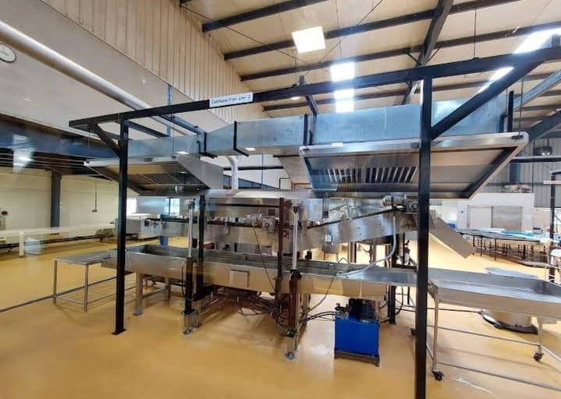

C. Seasoning
Seasoning adds flavor to the snacks, which can be done manually or automatically.
Manual Seasoning: In smaller batches or for specialty products, workers manually sprinkled seasonings onto the snacks, ensuring even coating.
- Semi-Automatic Seasoning: This involved workers pouring seasoning into machines that evenly distributed the flavor onto the snacks as they moved through rotating drums.
- Fully Automated Seasoning: Large-scale production lines used automated seasoning systems that calculated the exact amount of seasoning needed, ensuring each snack was evenly coated without wastage.

4. Packaging
Packaging is crucial in preserving the freshness of the snacks. "Tasty World" uses both manual and automated methods for packaging:
- Manual Packaging: For small, custom orders, workers hand-packed snacks into bags, ensuring accuracy and quality control.
- Semi-Automatic Packaging: Workers loaded the snacks into semiautomated packing machines, which sealed the bags and added labels.
The human element ensured flexibility for different bag sizes and flavors.
- Fully Automated Packaging: The high-speed packaging system automatically filled, sealed, and labeled the bags. The machines handled large volumes, ensuring high output while maintaining hygiene and quality.

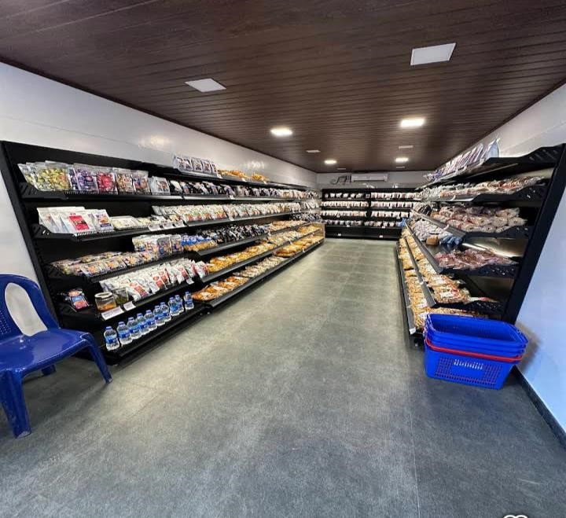

5. Quality Control
Throughout the production process, quality control is essential. "Tasty World" employs various levels of quality checks.
- Manual Quality Control: Workers inspected batches of snacks visually, checking for defects, burnt chips, or uneven seasoning.
- Semi-Automatic Quality Control: Machines assisted workers by using cameras and sensors to detect abnormalities in the product, which were flagged for human review.
- Fully Automated Quality Control: Advanced systems, using cameras, sensors, and algorithms, monitored the production process, rejecting faulty snacks automatically. This process ensured that only high-quality products reached the packaging stage.
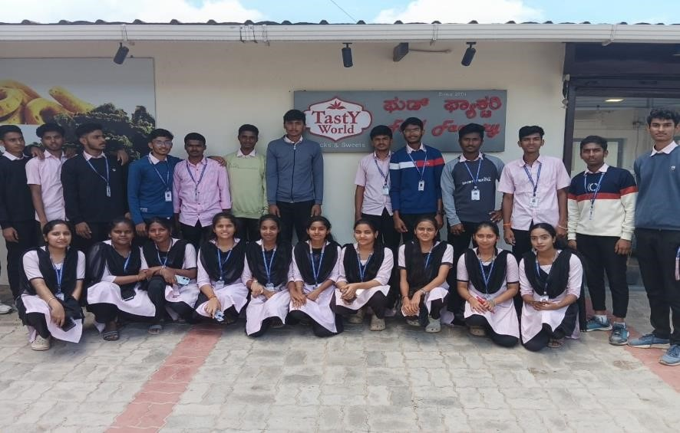

6. Conclusion
The visit to "Tasty World" provided a comprehensive understanding of how snacks are produced on a large scale, utilizing a combination of manual, semiautomatic, and fully automated processes. The integration of these methods allows the company to balance efficiency, product quality, and flexibility, ensuring that they can cater to both high-volume orders and specialty products. The manual processes offer flexibility and attention to detail, semiautomation enhances efficiency while retaining some human control, and full automation drives mass production with minimal human intervention.

